PMI Video Jet Laser Print

Revision Log

The below table lists the modification history for this document:
No. | PIC | Last update | Ticket# | Change description
1 | Dekie | 2022-08-03 | 140308-01 | Initial version
2 | Dekie | 2023-01-17 | 140308-02 | Support to config specified SN type to be sent to laser machine.
3 | Dekie | 2023-03-14 | 140308-03 | Support both C2S_DATACHK_OK and C2S|DATACHK_OK
4 | Dekie | 2023-04-18 | 140308-04 | 1. Auto-hidden the SNFormat option when tick “Obtain Unit SN by UDP” option.  2. Support to format the SN before being sent to laser machine by configurable UDP.

Content

1. Instruction of Deploying 4
2. FF CoMA 5
2.1 Route sample 5
2.1.1 Sample route 5
2.2 Task settings 7
2.2.1 Task settings 7
2.3 Label Sample 10
2.3.1 Create Label 10
2.4 Configure Detail attributes 11
2.4.1 Need to configure below Part Family Detail attributes value. 11
2.4.2 Need to configure below Part Detail attributes value. 11
2.4.2 Add PO Detail settings 11
2.5 Configure SN Format 12
2.5.1 Define SN Format 12
2.6 Configure Access right 13
2.6.1 Group Access control for n/a. 13
2.7 UDP Sample 14
2.7.1 UDP Sample for udpPMISampleObtainUCSN 14
2.7.2 UDP Sample for udpPMISampleExtraValidation 15
2.7.3 UDP Sample for udpPMISampleFormatLaserCommandSN 16
3 FF External Module 18
3.1 FCS Signal Manager 18
3.1.1 n/a 18
4 FF Client 19
4.1 Main UI for Scanning Unit 19
4.2 Main UI for PNUC 20
4.3 Main UI for POUC 21
5 FCS 22
5.1 n/a Signal 22
5.1.1 Settings for Signal Structure 22
5.1.2 Settings for Data Flow 22
5.2.1 UDP Interface for n/a Signal 22
6 FF Reports 23
6.1 Reports UI 23
7 Other Configuration 23
7.1 n/a 23

1. Instruction of Deploying

Pre-conditions
Please ensure to deploy the solution firstly: Toolkit FlexFlow TCPIP+SDK 1.0.0.104
No. | Script file | Version | Description
1 | 001 PMIVideoJetLaserPrint_SC.sql | 2.8.24.101 | Register new UDT tables
2 | 002 PMIVideoJetLaserPrint_DC.sql | 2.8.24.101 | Register language
3 | 003 PMIVideoJetLaserPrint_TC.sql | 2.8.24.101 | Register new basic function and template
4 | 004 udpPMILaserRegisterUnit.sql | 2.8.24.101 | Will register unit
5 | 005 udpPMILaserXMLExtraData.sql | 2.8.24.101 | Will parser the xml detail
6 | 006 udpPMILaserSaveOperationLog.sql | 2.8.24.101 | Will store the operation log info
7 | 007 udpPMICompleteLaserAction.sql | 2.8.24.101 | Will complete the whole laser actions and change unit state to next station
8 | 010 udpPMISampleObtainUCSN.sql | 2.8.24.101 | Sample UDP to obtain SN
9 | 011 udpPMISampleExtraValidation.sql | 2.8.24.101 | Sample UDP to do extra validation
10 | UpdatefsDBInfoScript.sql | na
FF Client
1 | PMIVideoJetLaserPrint.dll | 2.8.24.104 | Copy this DLL into FF application Client folder

2. FF CoMA

2.1 Route sample

2.1.1 Sample route
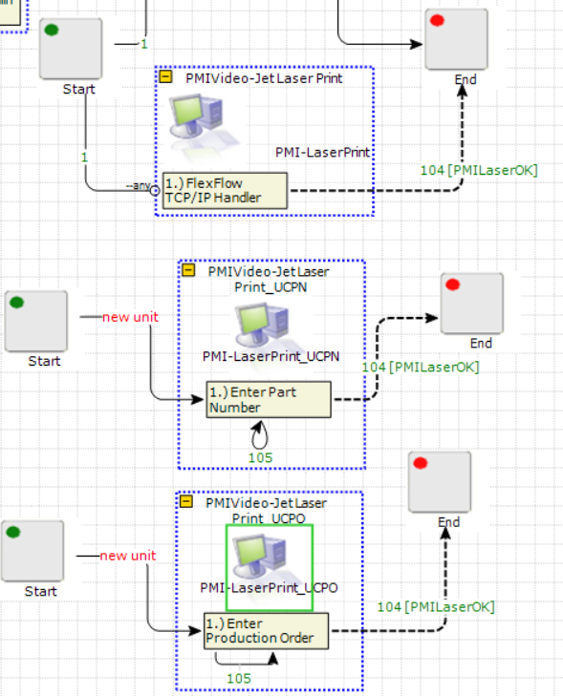
2.1.1.1 what template should be applied:

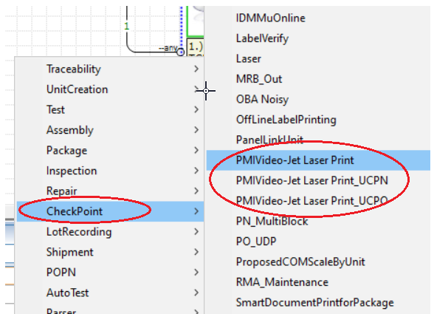

Notes
After you execute the TC script file, the above templates will appear within the right menu, you can put it into any task group where you want to put.

2.2 Task settings

2.2.1 Task settings

2.2.1.1 Laser Printing settings by scanning.

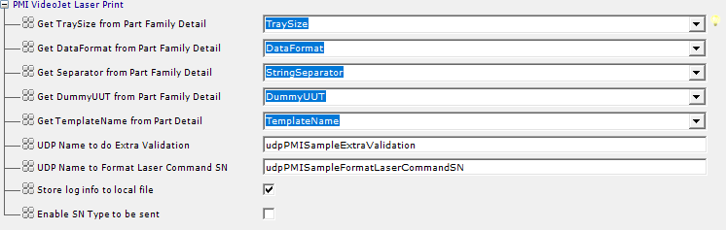

2.2.1.2 Laser Printing settings by PNUC.

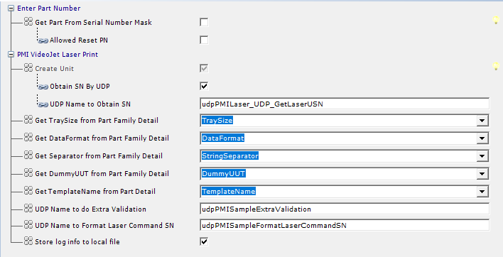

2.2.1.2 Laser Printing settings by POUC.
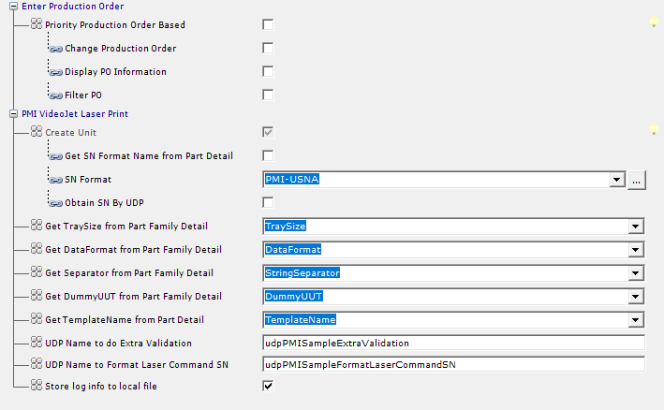

Task setting name | Description
Create Unit | Will auto-tick and display when a “new unit” line links to this station in Route, otherwise will be invisible.
Get SN Format Name from Part Detail | Will decide if need to get SNFormat from Part Detail
Attribute Name from Part Detail | Specify the attribute name which store the SN Format in Part Detail
SN Format | Specify the SN Format name form ffSNFormat table.
Obtain SN By UDP | Will decide if need to obtain Unit SN through configurable UDP
UDP Name to obtain SN | Set the UDP name which will perform the extra validation.(Refer sample: udpPMISampleObtainUCSN)
Get TraySize from part family detail | Specify the attribute name which store the TraySize in Part Family Detail
Get DataFormat from part family detail | Specify the attribute name which store the DataFormat in Part Family Detail
Get Separator from Part Family Detail | Specify the attribute name which store the Separator in Part Family Detail
Get TemplateName from Part Detail | Specify the attribute name which store the TemplateName in Part Detail
UDP Name to do Extra Validation | Set the UDP name which will perform the extra validation.(Refer sample: udpPMISampleExtraValidation)
UDP Name to format laser command SN | Set the UDP name which will assign the specified sn format and send to the video jet software.  . (Refer sample: udpPMISampleFormatLaserCommandSN)
Store Log Info to local file | If it’s ticked, will store the operation log into LogFiles folder under the same as the FlexFlow client.
Enable SN Type to be sent | Will decide if need to enable the feature to specify the tracking SN Type
Unit Tracking SN Type | Specified the tracking sn type to be printed by laser machine.

Note:

2.3 Label Sample

2.3.1 Create Label

Note:
N/A

2.4 Configure Detail attributes

2.4.1 Need to configure below Part Family Detail attributes value.
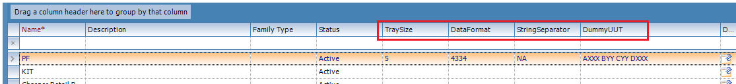

2.4.2 Need to configure below Part Detail attributes value.
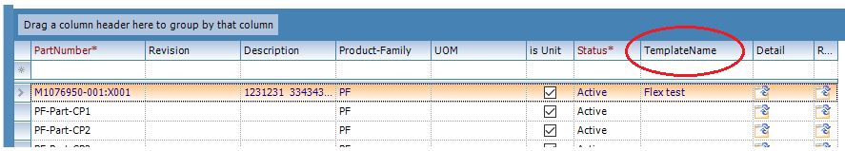

Note
N/A

2.4.2 Add PO Detail settings

Note
N/A

2.5 Configure SN Format

2.5.1 Define SN Format

Note
N/A

2.6 Configure Access right

2.6.1 Group Access control for n/a.

Note
n/a

2.7 UDP Sample

2.7.1 UDP Sample for udpPMISampleObtainUCSN

CREATE PROCEDURE [dbo].[udpPMISampleObtainUCSN]
@xmlUnitSN text=null,
@xmlProdOrder text=null,
@xmlPart text=null,
@xmlPackages text=null,
@xmlStation text=null,
@EmployeeID int,
@xmlExtraData varchar(max)=null
As
Declare @ret int

--Get the SN Qty
Declare @SNQty int
exec @ret = uspXMLExtraData @xmlExtraData, 'SNQty', @SNQty output

--Define your own logics to obtain the Unit SN from someplace.
Select Top(@SNQty) [Value] as SN from ffSerialNumber Order By UnitID Desc

Return 0

GO

Note
- This sample interface is show you how to customized your own UDP, and returned unit serial to Client.

2.7.2 UDP Sample for udpPMISampleExtraValidation

CREATE PROCEDURE [dbo].[udpPMISampleExtraValidation]
@xmlUnitSN text=null,
@xmlProdOrder text=null,
@xmlPart text=null,
@xmlPackages text=null,
@xmlStation text=null,
@EmployeeID int,
@xmlExtraData varchar(max)=null
As

--Put your validation codes

Return 0

GO

Note
- This sample interface is show you how to customized your own UDP and doing some extra validation based on project requirements.

2.7.3 UDP Sample for udpPMISampleFormatLaserCommandSN

CREATE OR ALTER PROCEDURE [dbo].[udpPMISampleFormatLaserCommandSN]
@xmlUnitSN varchar(max)=null,
@xmlProdOrder varchar(max)=null,
@xmlPart varchar(max)=null,
@xmlPackages varchar(max)=null,
@xmlStation varchar(max)=null,
@EmployeeID int,
@xmlExtraData varchar(max)=null
As

Declare @retValue int

Declare @PartID INT, @PartNumber varchar(200)
Set @xmlPart = REPLACE(@xmlPart,'<?xml version="1.0" encoding="ISO-8859-1"?>',N'')
EXEC @retValue= dbo.uspXMLPart @xmlPart,@PartID OUT,@PartNumber OUT
IF @retValue<>0 RETURN @retValue

Declare @StationID INT, @StationTypeID INT , @LineID INT
Set @xmlStation = REPLACE(@xmlStation,'<?xml version="1.0" encoding="ISO-8859-1"?>','')
EXEC @retValue= dbo.uspXMLStation @xmlStation,@StationID OUT,default,@StationTypeID OUT,@LineID OUT
IF @retValue<>0 RETURN @retValue

Declare @xmlFormatSN varchar(max), @DataFormat varchar(200), @StringSeparator varchar(200)
Set @xmlExtraData = REPLACE(@xmlExtraData,'<?xml version="1.0" encoding="ISO-8859-1"?>','')
exec @retValue = udpPMILaserXMLExtraData @xmlExtraData, 'FormatSN', @xmlFormatSN output
exec @retValue = udpPMILaserXMLExtraData @xmlExtraData, 'DataFormat', @DataFormat output
exec @retValue = udpPMILaserXMLExtraData @xmlExtraData, 'StringSeparator', @StringSeparator output

declare @ExtraData table (
[ID] int identity(1,1),
orgSN varchar(200),
formattedSN varchar(200))
Declare @xml xml
Set @xml = cast(@xmlFormatSN as xml)

insert @ExtraData (orgSN)
SELECT
col.value('.','nvarchar(max)')
FROM @xml.nodes('/DT/D') tab(col)

If @DataFormat='88' Begin
Update @ExtraData Set formattedSN = [dbo].[udfPMILaserGetFormatSN](orgSN,'4334',@StringSeparator)
Update @ExtraData Set formattedSN =SUBSTRING(formattedSN,1,8)+ @StringSeparator + SUBSTRING(formattedSN,10,8)
End else
Update @ExtraData Set formattedSN = [dbo].[udfPMILaserGetFormatSN](orgSN,@DataFormat,@StringSeparator)

Select ID, orgSN, formattedSN from @ExtraData Order By ID

Return 0

GO

Note
- This sample interface is show you how to customized your own UDP and format the unit sn before sending to laser software.

3 FF External Module

3.1 FCS Signal Manager

3.1.1 n/a

Note:
n/a

4 FF Client

4.1 Main UI for Scanning Unit

4.1.1 Client Task
a.) PMI VideoJet Laser Print
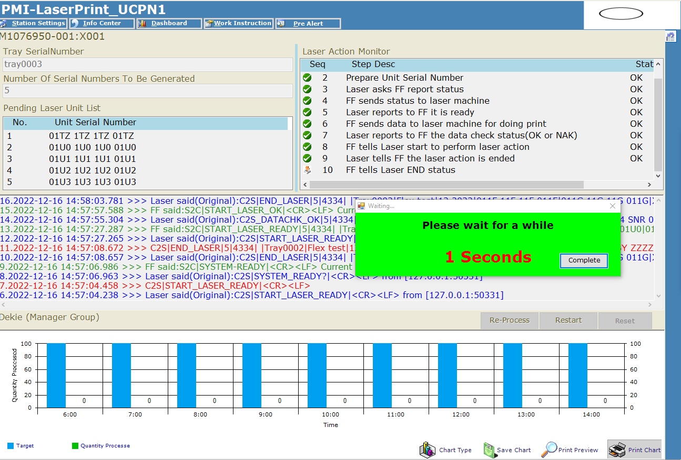

Note:

4.2 Main UI for PNUC

4.2.1 Client Task
a.) Enter Part Number -Sepecified the part number
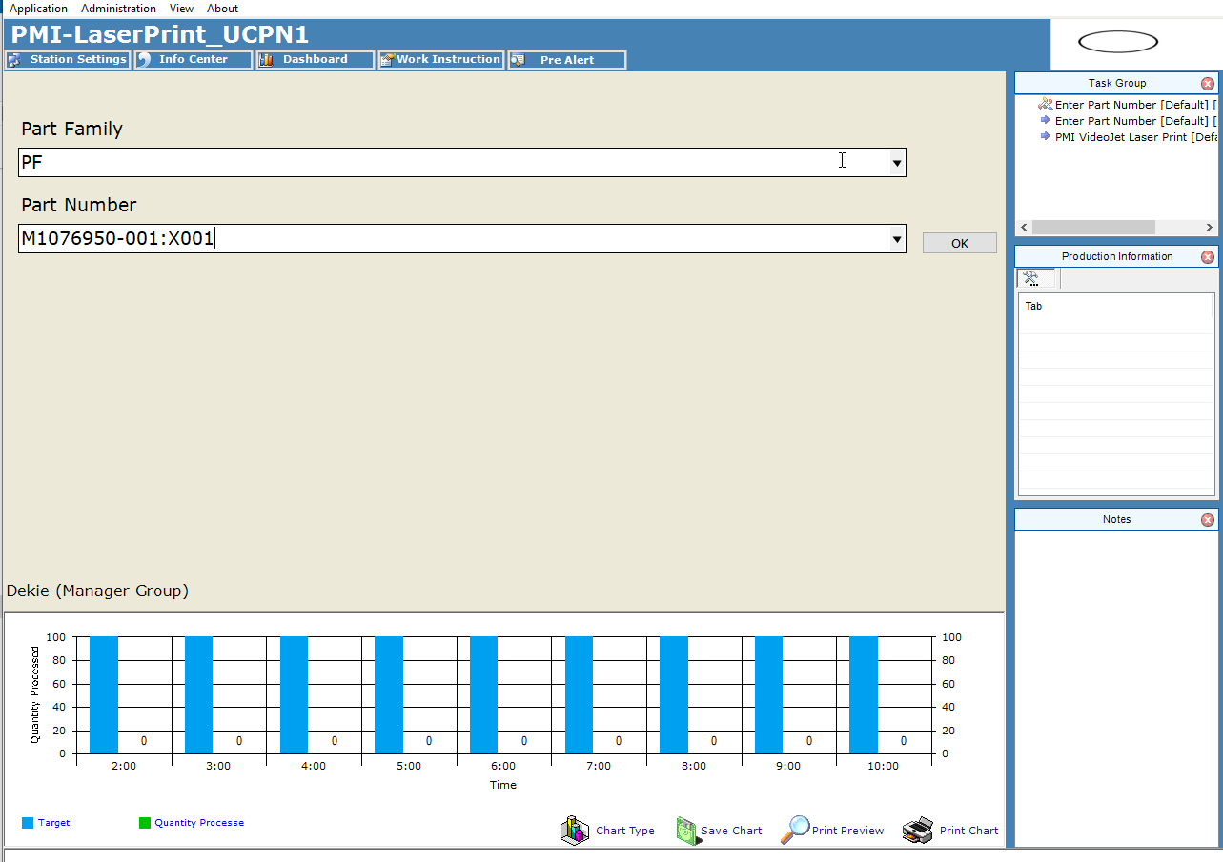

a.) PMI VideoJet Laser Print

Note:
Not allow to go to next page till it reaches the time limitation.

4.3 Main UI for POUC

4.1.1 Client Task
a.) Enter Production Order -Sepecified the Production Order
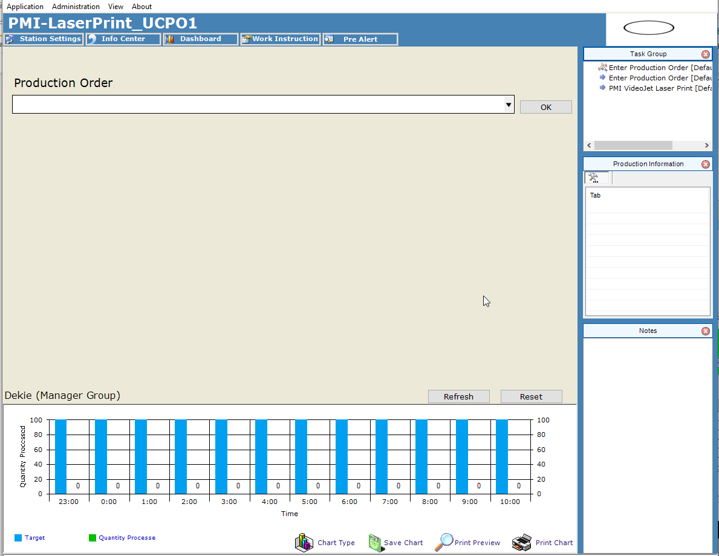

a.) PMI VideoJet Laser Print

Note:
Not allow to go to next page till it reaches the time limitation.

5 FCS

5.1 n/a Signal

5.1.1 Settings for Signal Structure

Note:
n/a

5.1.2 Settings for Data Flow

Note:
n/a

5.2 Signal Standard UDP interface sample

5.2.1 UDP Interface for n/a Signal

Note:

6 FF Reports

6.1 Reports UI

Note:
n/a

7 Other Configuration

7.1 n/a

Comments for the special logic:
n/a

